***Remembering Joan Robinson – 6 March 2022***

*About thirty past and current members, and friends met up at Joan’s home in Rathmines to reflect on her wonderful, generous life and the contribution she made to each of us and Ramblers Bushwalking Club. We met at 11.00am for several hours of catching up and sharing stories and memories of Joan. Thanks, Sue, for organising the occasion.*

*Those present were Barry and Elaine Collier, Elaine Dyall, Val and Robert Gascoigne, Vicki Ross, Ann See, Ingrid Waeger, Malcolm Mills, David Morrison, Jenny Whyte, Jill Clifford, Annie Devine, Arthur Radford, John Simpson, Sandra Waeger, Anne Clarke, Angela Longworth, Alan Wright, Karl Cwach, Carol Bastian. Bob Clifton, Sue Shaw, Ros McCleod, Rosemary and Steve friends of Sue, Leanne Hines, and Greg Powell*

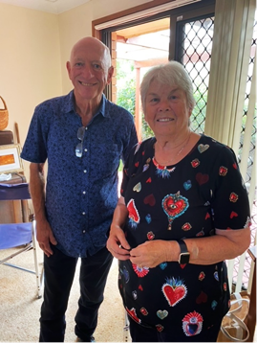

*

*We were not sure when Joan became a life member of the Ramblers. David found her certificate amongst her collection of books and memorabilia*